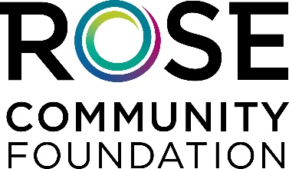

Practice Scenario 2

You are: The Solicitor

You will be speaking with:

The new board member who loves your organization and is a rising star with a lot of leadership potential. They are married with three young kids and are making meaningful gifts to your organization, $1000 for the past two years. They are 45 years old. They believe the organization is very important to the community. It is time to solicit for the annual campaign and they are a prospect for your capital campaign. Your organization has to renovate a building that is essential to your mission, and you also would like them to invest in the endowment fund as well. The board member doesn’t have a will yet because the spouses can’t agree on a guardian for their children. You are going to ask for all three gifts (annual, capital and endowment) during one conversation.

Your job is to:

- Call the donor and schedule an in person visit.
- At the meeting, have a conversation – find out why she/he is a committed loyal supporter of your organization.
- Your goal is to thank them, keep them as a consistent donor to the annual campaign and try to secure them investment in the capital campaign and endowment fund. Consider asking for an appropriate type of future gift like a gift in a will, retirement fund, or life insurance policy.
- For the annual gift try to get an increase in the amount.
- Respond as necessary given the conversation and schedule another meeting if need be.

Practice Scenario 2

You are: A New Board Member

You are a new board member and a rising star in the organization’s leadership. You are 45 years old with three children. You don’t have a will yet because you and your spouse can’t agree on a guardian for your children. You know the solicitor well. You have been making meaningful gifts of $1,000 every year.

You feel this organization is very important. The organization is undergoing a capital campaign and an endowment campaign to pay for the repairs which will be needed on the building. The current building is in desperate need of renovation and it is essential to the mission of the organization. You are trying to figure out the benefits of an endowment fund. You need to get your will done and are worried that it isn’t done yet. You want to leave your money to your children in your will.

Your job is to:
- “Meet” with the organization’s representative
- Raise objections as they come up.
- Eventually agree to something - an increase in annual giving and/or an investment in the capital campaign and/or endowment fund through either a current or future gift.

