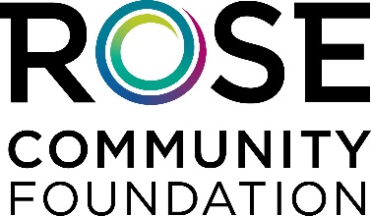

Practice Scenario 1:

You are: The Solicitor

You will be speaking with:

The longtime consistent donor who has given $100 every year for 20 years. They are 65 years old. They believe the organization is very important to the community. As a retiree, they are concerned about having enough money to live on in the future. They have no children. Their investments took a hit recently.

Your job is to:

- You have already called the donor and scheduled an in-person visit.
- During the visit, have a conversation – find out why they have been such a consistent supporter of the organization.
- Your goal is to thank them and try to secure their investment in the endowment fund. Consider asking for an appropriate type of future gift like a gift in a will, trust, retirement fund, or life insurance.
- Respond as necessary given the conversation and schedule another meeting if need be.

Practice Scenario 1:

You are: The Long-time Supporter

You have been a modest donor ($100) every year for 20 years. You feel this organization is very important. You are retired and your investments took a bit of a hit recently. You are single and a little concerned about your situation but not enough to stop giving annually.

Your job is to:
- “Meet” with the organization’s representative
- Raise objections as they come up.
- Eventually agree to something - either another visit or an endowment investment, either through a current or legacy gift.

