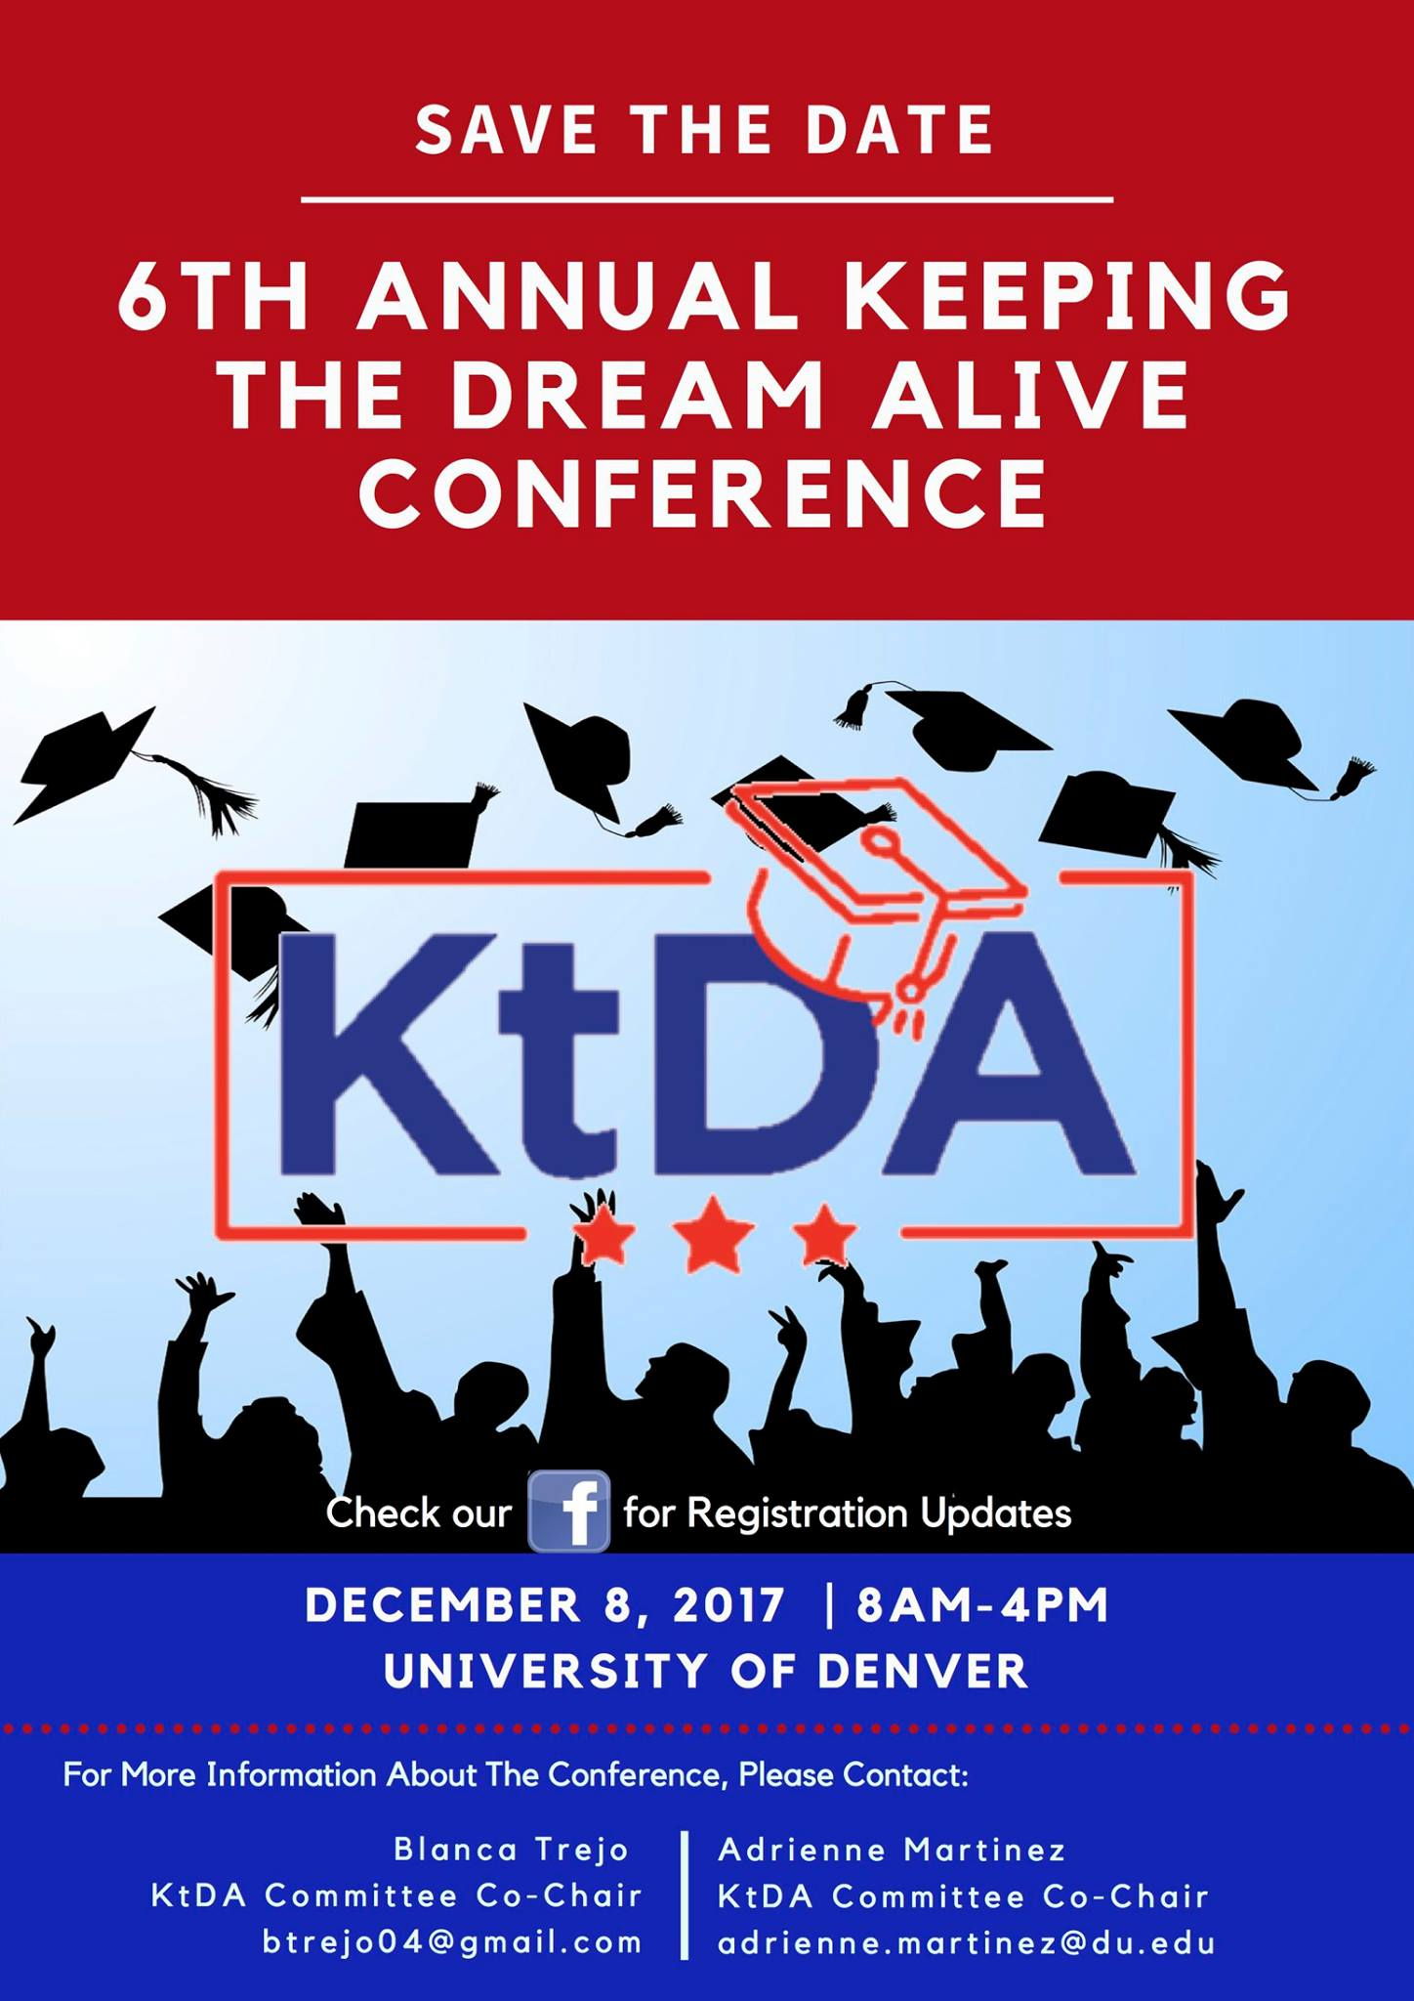
Colorado DREAMer Ally Network

Recommendations & Resources
for Dreamers & Allies

DACA or Deferred Action for Childhood Arrivals
DACA ended on Sept. 5, 2017. No new applications. If your application is pending, you will receive it. If you are renewing DACA, move forward with caution and you can renew by October 5 if your permit will expire between September 5 and March 5. This information comes from National Immigration Law Center and United We Dream.
ASSET
CO ASSET (SB13-033) is state law that has not changed and will not change in the near future. ASSET is in state tuition for eligible Colorado residents pursuing higher education. Go here for more details: www.ciccoloradoasset.org

To find out if you qualify, click here: https://www.ccd.edu/administration/non-academic-departments/asset-daca/what-colorado-asset-bill

College Opportunity Fund (COF)
COF Funds are a part of the CO ASSET law and are available to ASSET students pursuing higher education.

FAFSA (Free Application for Federal Student Aid for college students)
If you are DACA or undocumented or if your parents are undocumented and even if you are a permanent resident or U.S. Citizen, ask the financial aid office of the college/university you plan to attend if they have an alternative financial aid form you can use instead of the FAFSA. Consider using a P.O. Box for your mailing address. FAFSA information is sent to Homeland Security and other offices where legal status might become an issue. Ask before you fill it out!

K-12 Resources
Denver Public Schools put out letters and statements informing families and students of their rights under the law and ensuring school safety for all students. Please consider having your school/district do something like this.
https://www.dpsk12.org/responding-to-immigration-concerns/
https://www.dpsk12.org/dps-board-reinforces-schools-safe-for-all-students/

Sanctuary Campus Information
K-12 Sample Campus Sanctuary Policy: https://www.dpsk12.org/safe-and-welcoming-school-district/
University of California’s Policy:
https://www.universityofcalifornia.edu/press-room/university-california-releases-principles-support-uc-community-members
Cosecha Movement’s Suggestions for Sanctuary Campus Language
https://docs.google.com/document/d/1KFs5A_VpYHGaSLOROhEQKyRsPVfDiEV1t_iPe2p2RB4/edit

For Educators Hoping to Hold Supportive Discussions
http://tinyurl.com/k12electionresources or http://goo.gl/jxCiNz

For Students
http://aclu-co.org/know-your-rights/#
This website has a great section on Students’ Rights at Public Schools including information about your rights to protest and a section on discrimination on the basis of sexual orientation in public businesses.

DACA Action and Support Groups in Colorado
Caminando Unidos (DACA students at UNC) CCD Dreamers United- Find on Facebook
Dreamers United @ CSU- Find on Facebook CU Dreamers- Find on Facebook
UndoCommittee & Auraria Dreamers (Closed Facebook Group)

Know Your Rights
Know Your Rights workshops and events are being held across the state. To find one near you or to organize one: go to www.padresunidos.org

Is there ICE activity in your neighborhood? Have you been detained because of your immigration status? Call the Colorado Rapid Response Network at 1-844-864-8341. Information will be kept confidential.

If you face discrimination, intimidation or harassment, contact:
U.S. Department of Justice, file a complaint with the Civil Rights Division
https://www.justice.gov/actioncenter/submit-complaint
Education 877-292-3804 or 202 514-4092
Employment 800-669-4000 (voice)

Useful Websites:
My Undocumented Life
https://mydocumentedlife.org/2016/11/13/post-election-recommendations-for-school-administrators-educators-counselors-and-undocumented-students/

Immigrant Legal Resource Center
https://www.ilrc.org/immigrant-youth

Educators 4 Fair Consideration
http://e4fc.bmeurl.co/6984436

United We Dream
http://unitedwedream.org/

National Immigration Law Center
https://www.nilc.org/

Colorado Immigrant Rights Coalition
http://coloradoimmigrant.org/

Padres and Jóvenes Unidos
https://padresunidos.org/

Rocky Mountain Immigrant Advocacy Network
http://rmian.org

Legal Resources in Colorado, including lists of immigration attorneys:
http://www.ciccoloradoasset.org/item/254-legal-resources

Save the Date. Dec 8, 2017. Keeping the Dream Alive Conference for Dreamers & Educators

